LAB 4 Thursday

2014/4

First, create a Frame (Frame Mama)

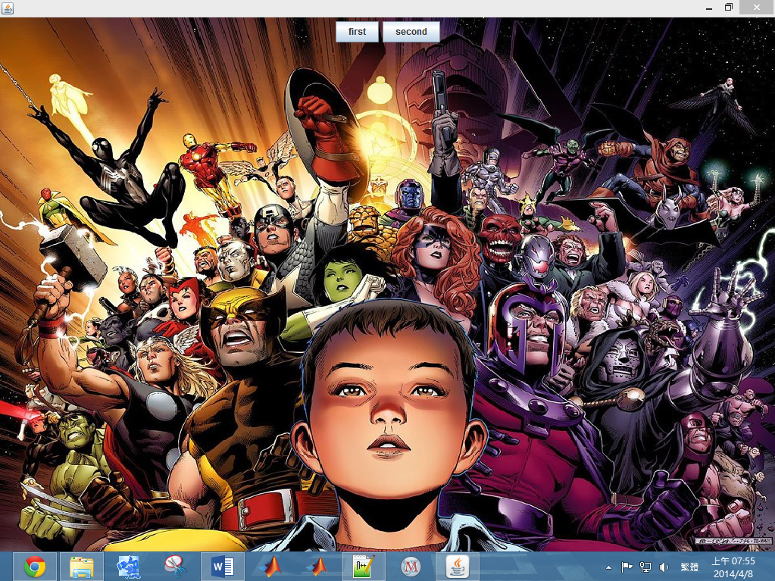

You must set this Frame’s size to max automatically when your program start.

And you need to add a panel you write to this frame with a picture draw on it.

This panel also contains two button, one is “first” the other is “second”

When user click first, one frame (Frame A) will be created with your panel, click again will destroy it. And notice that Frame A’s Panel is the same as your Frame mama’s. so these two button still work on it.

Now we open two frame (Frame A and Frame B)

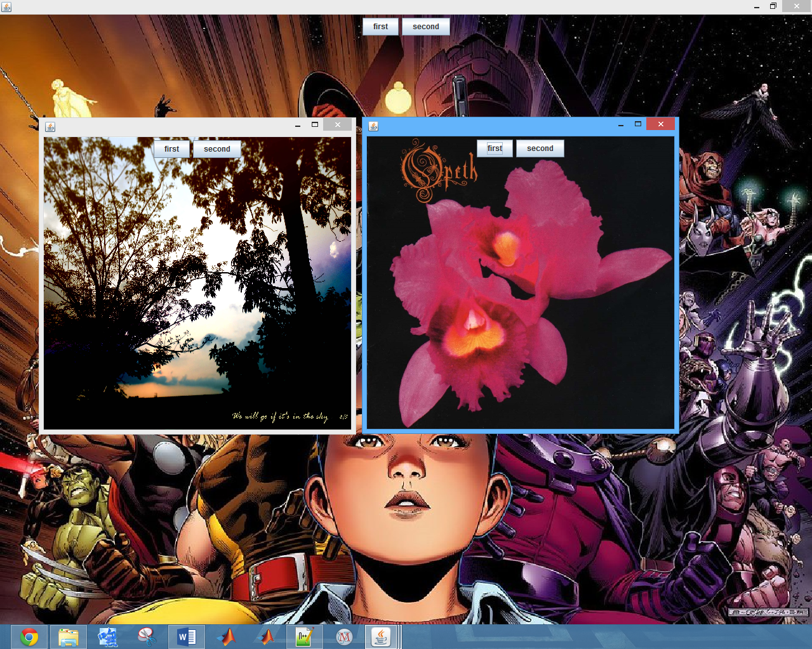

So, when you click the first button on Frame B, Frame A will be destroy.

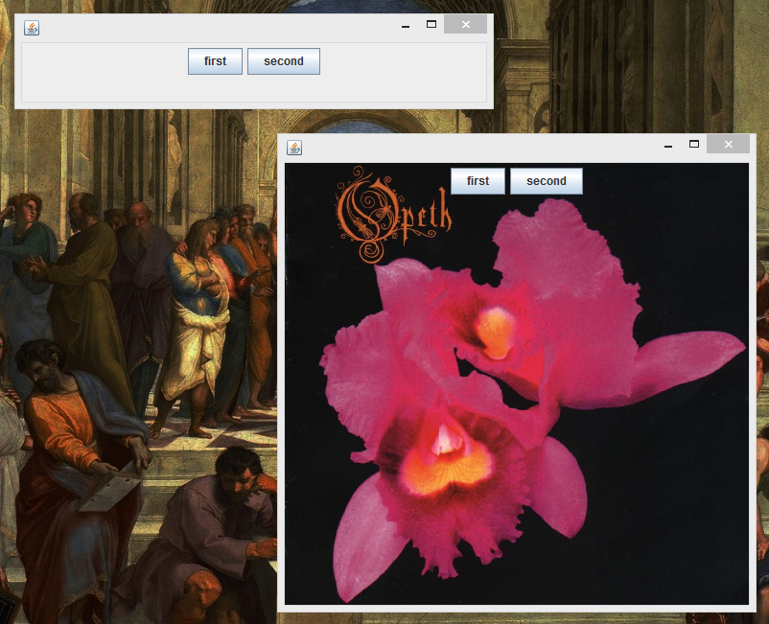

**HINTS:**

There are some thing you may need.

Image image = new ImageIcon(fileName).getImage();

g.drawImage(image,0,0,getWidth(),getHeight(),null);

event.getSource()

And you may need to go to java document to check JFrame’s members.

And also check **Frame’s** member for **Extend** the Boundary!